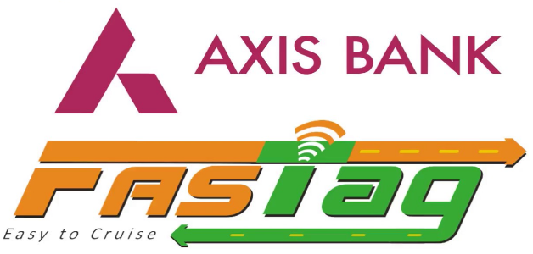

**User Portal Manual**

**Contents**

**User Portal Experience for Users**

**●User Portal Login**

**a. First Time User**

**●User Portal Layout**

**A. Road User Center**

1. **Manage Account**
2. **Service Request**
3. **Payment and Top-up**
4. **Reports and Statements**
5. **Download Wallet Statements**

**B. Operation Center**

**a. User Wallet Statement**

**C. Reports**

**a. Wallet Statement**

**Questions**

**●Forgot Your Password?**

**1800 419 8585 (toll free)**

**User Portal Experience for Users**

**The first time you enable this feature, you need to generate the Password**

**●First Time User**

**Click on the First Time User**

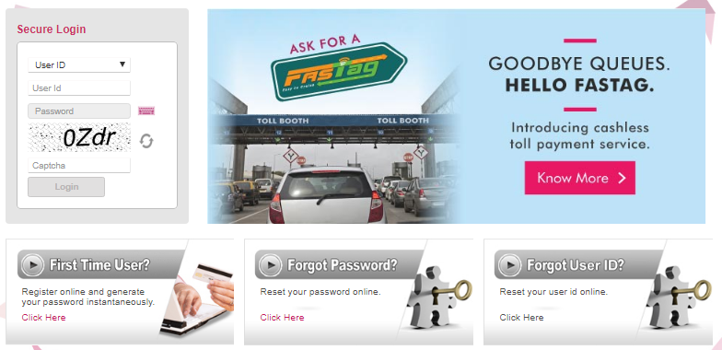

**Click here**

**Please fill in your information to continue to generate the password**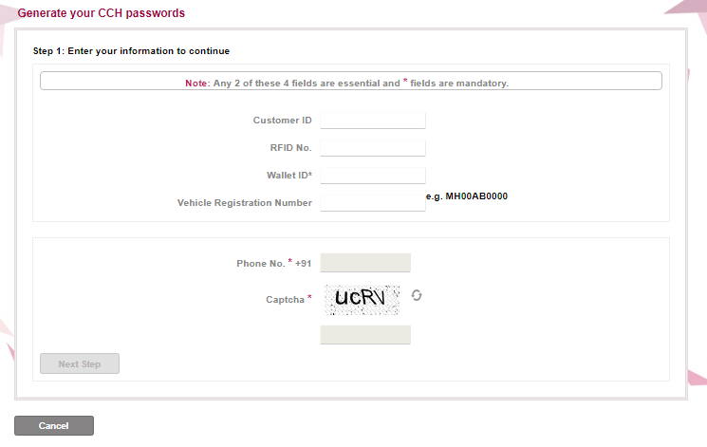

**Generate OTP to validate yourself and click on Continue.**

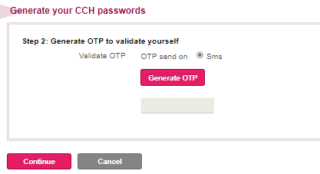

**Once the password gets generated you can click on Login (located next to Apply Now). The User needs to click on the LOGIN.**

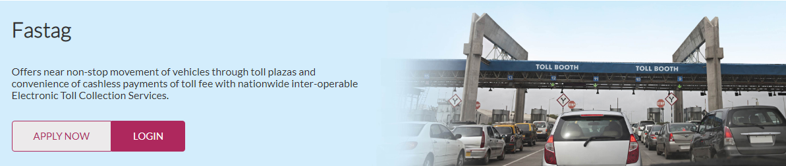

**Click Here**

**●User Portal Login**

**Under FASTag Login, the User can select the option from the dropdown and click on Login.**

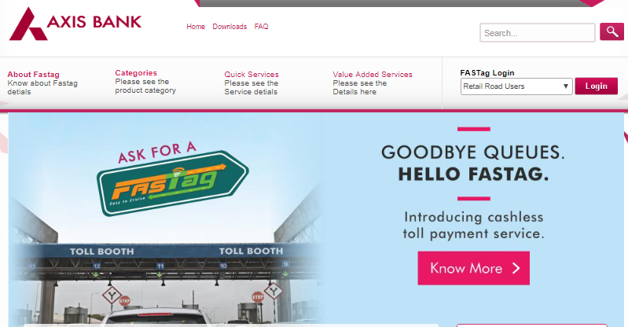

**Retail / Corporate option can be selected by the User from the dropdown**

**Enters the User ID and the Password following the Captcha and Login into the portal**

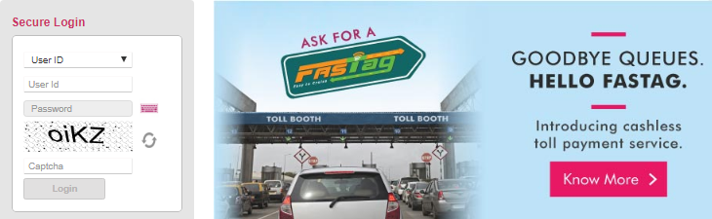

**Enter Credentials**

**●User Portal Layout**

**The User can access the Tag / Wallet related details from here:**

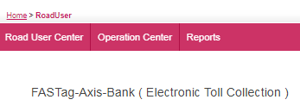

**A.Road User Center:-** Under this Tab, the User can select following options:-

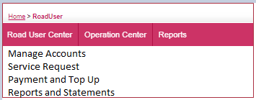

**a) Manage Account: -** Click on Road User Profile. User will able to see the his details, address details and FASTag Wallet Details

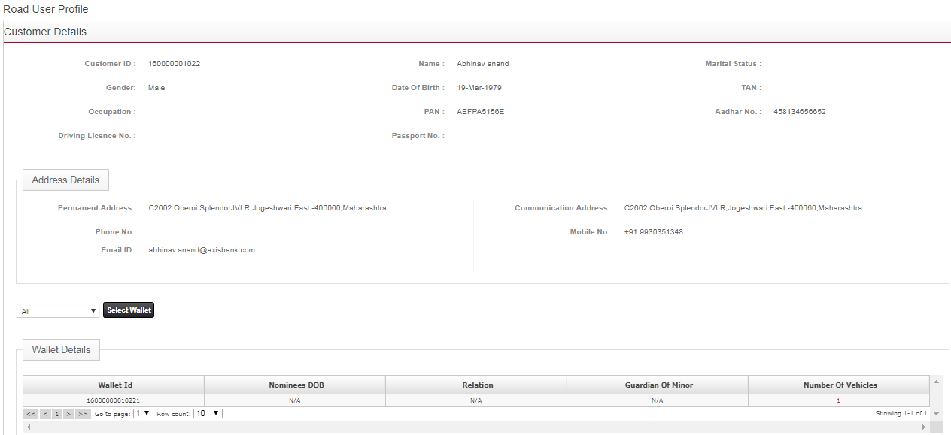

**Customer Details**

**Address Details**

**Wallet Details**

**On Clicking on Wallet ID, the user will be able to see the Vehicle Details, Account details and the Wallet Statement. The User can download the statement into excel.**

**Click on Wallet ID**

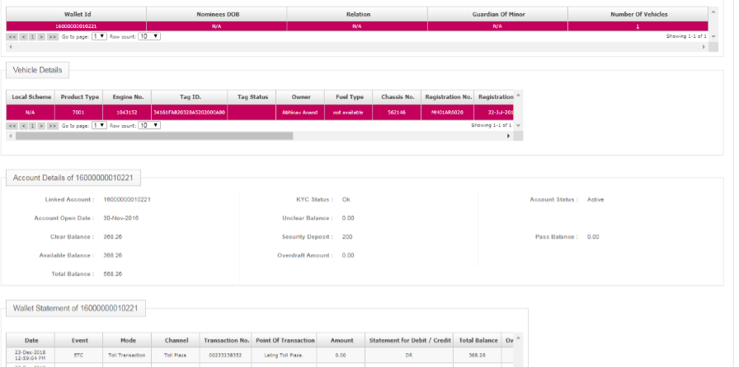

**Vehicle Details**

**Account Details**

**Wallet Statement**



**Export to Excel**

**b) Service Request : -** Click on Generate Service Request, User can raise and request through this option. The user can also upload the document.

**Select from the dropdown**

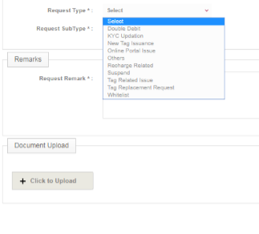

**Upload Document**

**c) Payment and Top up :-** The User will see two options under this – Recharge and Payment History

**Under Recharge –** The User has to select the Wallet ID. Enter the recharge amount and click on Recharge Amount

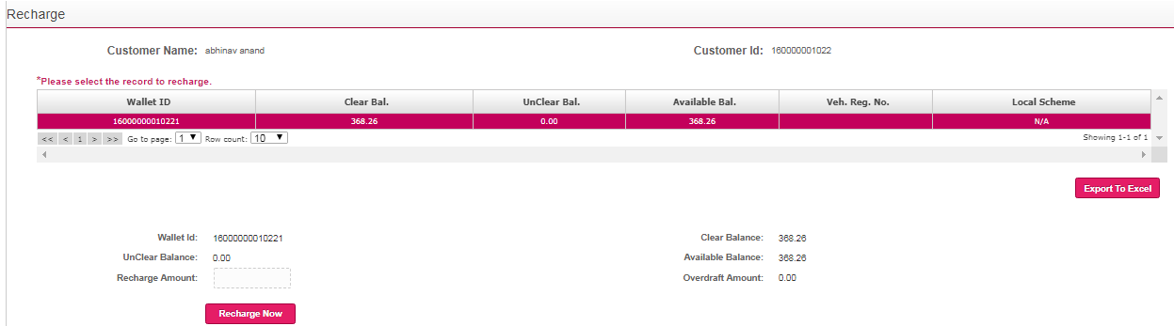

**Enter the recharge amount and click on recharge**

**Select the record**

**Under Payment History –** The User needs to select the date range and select on search. The User can export the report in excel.

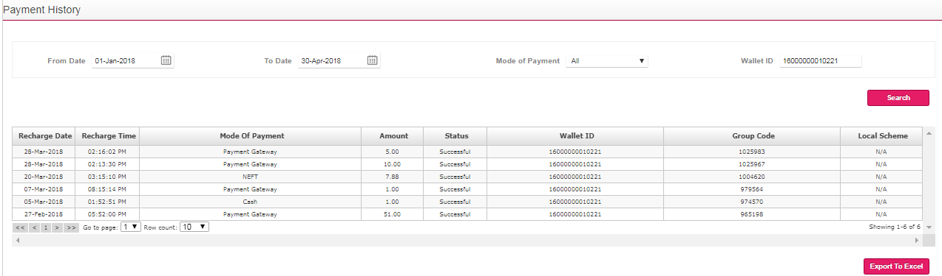

**Select the date range**

**d) Reports and Statements: -** The User can view the transaction details by selecting the date range and the Vehicle number. On Clicking on search the transaction details will get updated.

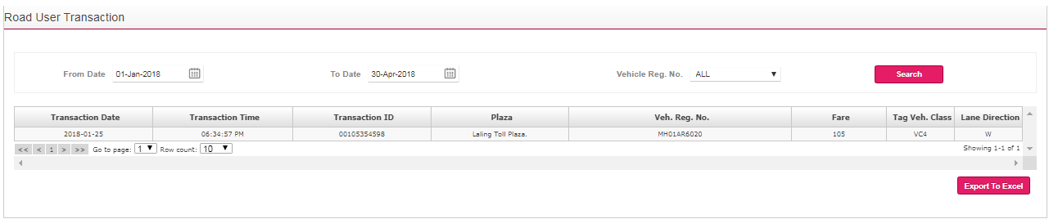

**Select vehicle number**

**Select the date range**

**B. Operation Centre:** The User can view User Wallet Statement option by selecting Toll Transaction or Wallet Debit option. Select the Date range and click on Search.

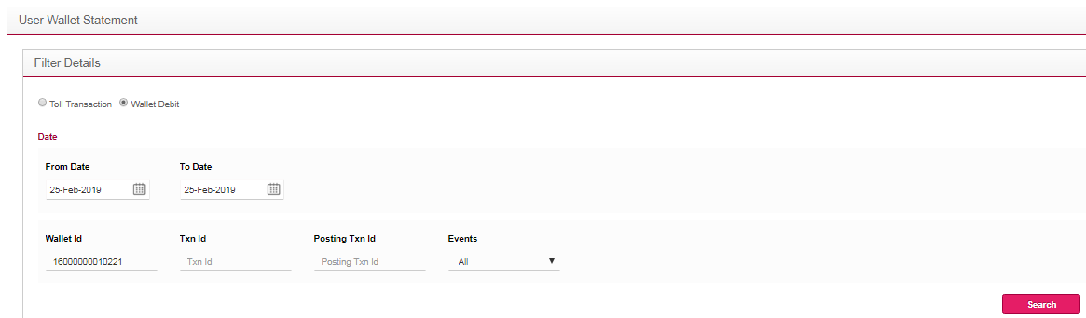

**Select Date range**

**Select Toll Transaction or Wallet Debit**

User Wallet Details will be fetched as below. The user can download the statement in excel.

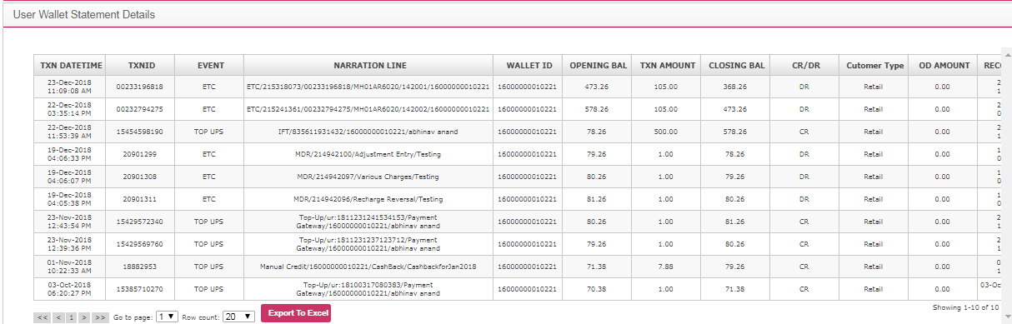

**C. Reports:-** The User can view and download the Wallet Statement. Select the Date range and click on generate report.

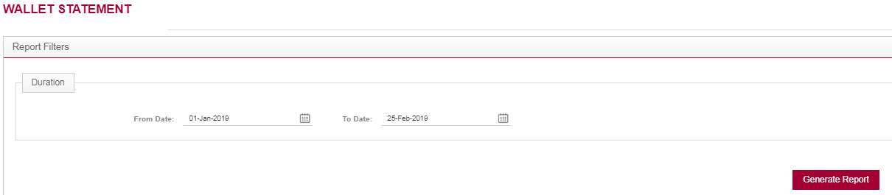

**Select Date range**

Wallet Statement gets downloaded. You can Export the report in XML, CSV, PDF, MHTML, Excel, Word, Tiff File.

. 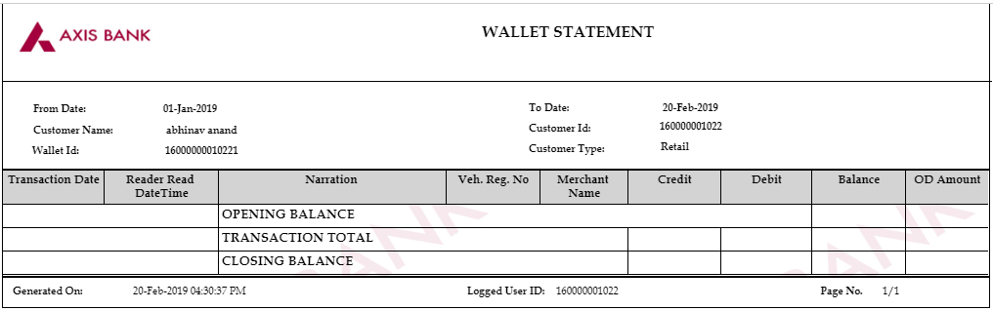

**Questions**

**●Forgot Your Password?**

**Incase the User is not recalling the password he can click on Fogot Password.**

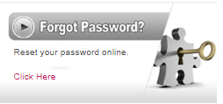

**The user need to enter his information and submit**

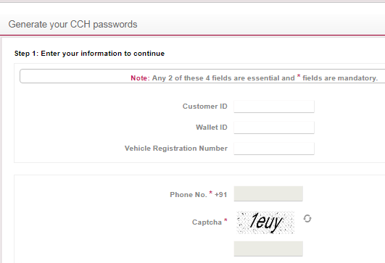

**Click on next. Enter the OTP to validate yourself and click on Continue**

